Designing Heuristically: A Classroom in Edmonton, CA
Julian Kotara

Pseudo Code:
Case 1: DF with translucent skylights
Import geometry from Rhino
Import TMY weather file
Combine sky and geometry into single model
Distribute lighting calculation points across floor at specified density and height
For every hour of the year
For each calculation point
Measure daylight hitting exterior roof geometry directly above calc point
Measure daylight reaching calc point
Divide light reaching interior point by light reaching exterior\
Record data and write to file
End
End
Average data per point to show annual daylight factor per point
Average data per year to show room annual daylight factor

Case 2: Static Louvers and Dimming
Import geometry from Rhino
Import TMY weather file
Combine sky and geometry into single model
Distribute lighting calculation points across floor at specified density and height
Read setpoint for required light level during room use
For every hour of the year when the sun is up + 1 on each side of day
For every calculation point
Record illuminance value
If illuminance value > 300 lx
Record date and time
Else
Ignore
Divide number of recorded hours by total number of operable hours
Compare to sDA metric being used and record if above or below metric
Output value as sDA300,50 percentage
If illuminance value >3000lx
Record date and time
Else
Ignore
Divide number of recorded hours by total number of operable hours
Compare to ASE metric being used and record if above or below metric
Output value as ASE percentage
For each lighting zone
Read value from photocell
Calculate dimming level from setpoint
Writing dimming percentage to file
End
End
Output dimming levels per zone per hour
Output hourly LPD for use in energy system

Case 3: Electrochromic Glazing
Import geometry from Rhino
Import TMY weather file
Combine sky and geometry into single model
Distribute lighting calculation points across floor at specified density and height
Read setpoint for required light level during room use
Place calc point as exterior photocell
For every hour with a vertical illuminance value
If photocell value is above 3000lx
activate glazing
Else
Deactivate glazing
End
For every hour of the year when the sun is up + 1 on each side of day
For calc point
calculate UDI by finding points outside of 100-3000lx
write UDI and illuminance to file
End
End
Report UDI values

Daylighting Metrics
Daylight Factor:
Daylight factor is the percentage of light reaching a certain point in a room compared to the amount of daylight hitting the roof. It provides a metric to analyze the efficiency at which daylight is brought into the space at a certain point. It can also be used to analyze areas and rooms if the values are averaged over multiple calculation points.
sDA:
Spatial daylight autonomy is a LEED percentage metric that sets a goal for the inclusion of daylight in a building throughout the year. sDA300,50 specifically requires that 300lx should be present on work planes for 50% of the operable hours of the building. Within LEED, the percentages to earn points are 55%, 75%, or 90%, which can be hard to achieve depending on building architecture and climate.
ASE:
Annual sunlight exposure helps determine the percentage of building space throughout the year that receives too much or too little sunlight, over 3000lx, for a certain number of hours per year, usually 250 hours a year. This is a good metric to balance out sDA as too much sunlight can create uncomfortable spaces, so by determining if too much daylight is entering the space, shading can be altered to ensure a more comfortable experience.
UDI:
The useful daylight index is another metric to analyze the amount of daylight in a space; however, it focuses on useful light, meaning there are bounds at the lower and upper ends of daylight illuminance to ensure useable daylight that is not too strong. The bounds are usually around 100lx to 3000lx (10fc to 3000fc), which is generally the range of daylight is comfortable for humans working in a space without being glary or not providing enough usable light.
Operation LPD:
Operational LPD is a more realistic version of a buildings LPD as it considers the dimming of lights throughout the space in response to daylighting. This lowers the actual energy usage from lighting; however, it makes it less predictable as daylight availability varies during the day.
Depending on the use of daylighting in the space, different metrics can be useful to look at the effects of sun on the space. Daylight factor is a rough way to understand the efficiency of light entering the space; however, it is a crude metric that does not provide much to the design or iteration of the space. sDA and ASE are very common metrics to understand the amount of useful light entering the space, with sDA providing the lower bound of usable light throughout the year and ASE providing the upper bound (when there is too much light). These are important aspects of daylighting points in the LEED and Well Building standards and are used pretty universally when architects and clients want to consider daylighting in a space. UDI combines both sDA and ASE into a single metric, measuring the amount of optimal daylight in a space throughout the year. This is the most advanced metric, only being considered by the most detailed daylight studies to completely understand sunlight and daylight in a space.

Virtual Modeling
Model 1: Daylighting Strategy from First Project
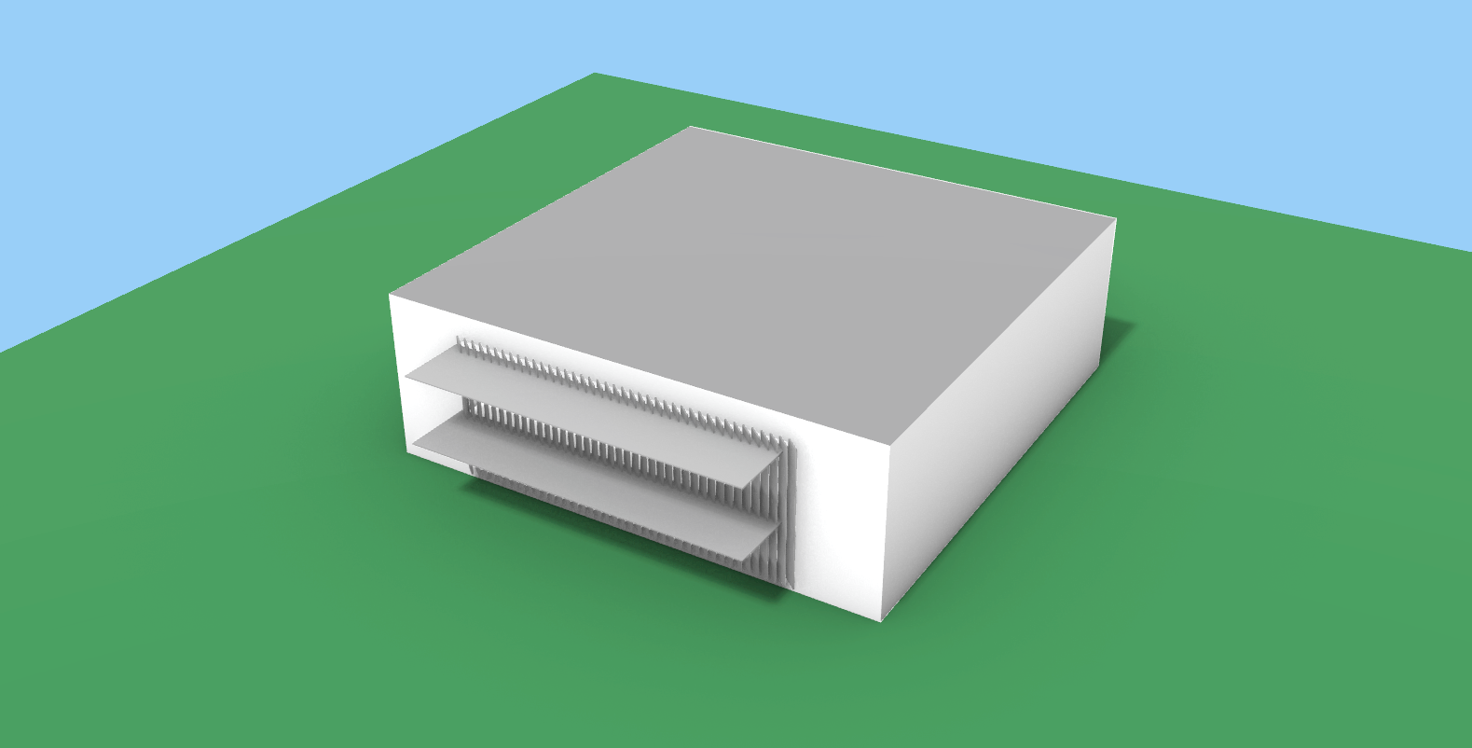
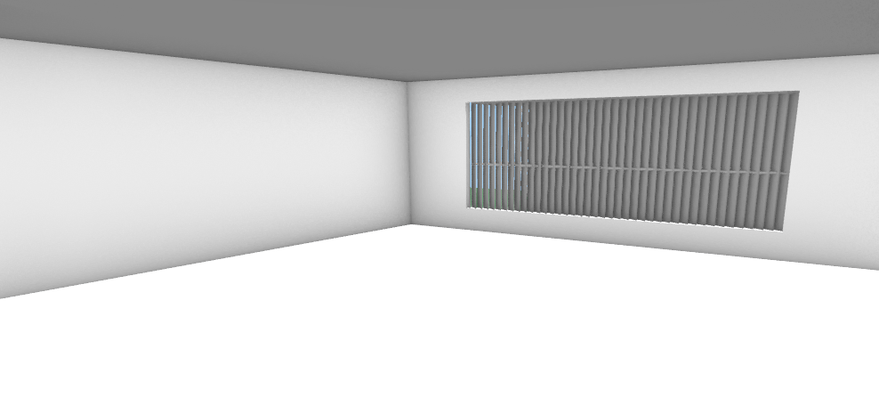
The first model was the same shading used for the first project, and based off initial tests, little to no useable daylight entered the space regardless of the time of year and time of day. It was clear that a new design was needed.
Model 2: Louvers with Clerestory Slit
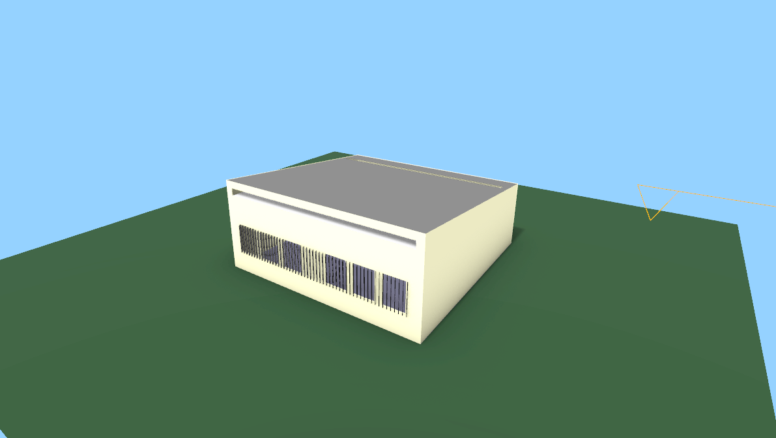
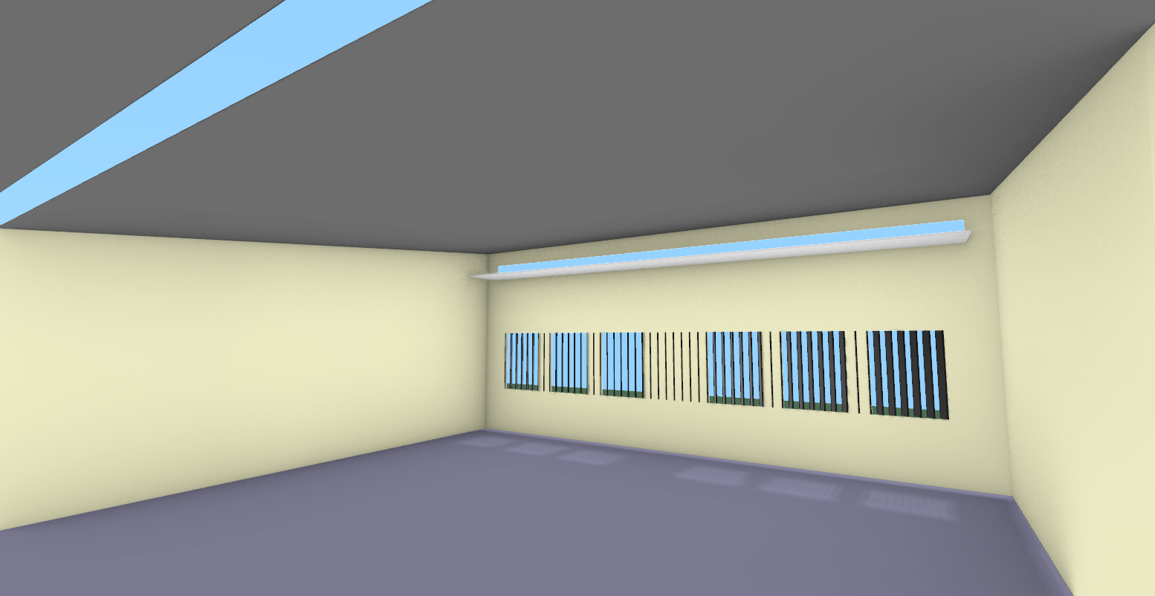
The second model focused on creating a better outward view, new methods of adding light to the space, and more detailed analysis of light in the space. The louvers in this model are less aggressive, only 20 degrees off vertical, however the windows they cover were split into six separate smaller windows to be in line with the 25% WWR required by the project. Rather than just utilizing a set of large windows on the south facade, two new openings were added. First, a thin clerestory was added to the south facade with a light shelf that both provides complete direct sunlight protection and reflects lights onto the ceiling to diffuse into the space. Additionally, a translucent skylight was added at the north side of the classroom to aid in light distribution to the back of the room and create a more even distribution across the room.
Initially the view glazing windows were connected in the center of the room, however this limited the amount of light near the walls and created dark patches, especially on the east facing walls. Additionally, the transmission of the skylight and windows were lowered to better control the visible light transmission into the space. Making these changes allowed even out distribution of light in the space and helped average some of the large illuminances present.
Data:
By collecting data from three different times on the winter solstice, summer solstice, and the equinox, most of the sky conditions present throughout the year are considered. All the data below is calculated using a sunny sky with sun to examine the brightest possible scenarios where shading techniques are the most important for occupant comfort. Throughout all the seasons, the values reflected the goal to provide daylight and heating in the morning and midday while restricting direct sun access and solar heat gain into the afternoon. While maximum values around the windows in the middle of the day were very high and might have to be accounted for in a different way, the minimum lux dropped below 100lx in the afternoons and winter mornings. The ASE percentages for the different spaces stayed relatively low, meaning there was not a lot of excess light in the space, creating a comfortable environment for students throughout the year. Lastly, a rough estimate of sDA300,50 was computed in excel, and it was found that over 57% of the room area met the requirements, which would earn two points in LEED scoring standards for being larger than 55%. The data showed effective shading and redistribution of light throughout the space most times in the year.
 |  | Average (lx) | Max (lx) | Min (lx) | 300 lux (%) | ASE (%)
6/21 | 9:00 AM | 1293.22 | 19613.4 | 154.1 | 63.83 | 4.08
 | 12:00 PM | 2176.08 | 26406.5 | 177.8 | 89.36 | 0.00
 | 3:00 PM | 97.78 | 257.5 | 27.2 | 0.00 | 0.00
9/21 | 9:00 AM | 380.33 | 994.2 | 155.6 | 61.70 | 0.00
 | 12:00 PM | 1328.09 | 20334.7 | 216.5 | 95.74 | 4.08
 | 3:00 PM | 362.56 | 699.6 | 149.3 | 61.70 | 0.00
12/21 | 9:00 AM | 165.32 | 393.7 | 43.5 | 12.77 | 0.00
 | 12:00 PM | 859.79 | 4412.5 | 112.3 | 48.94 | 14.29
 | 3:00 PM | 114.28 | 311.7 | 43.7 | 4.26 | 0.00
 | Avg | 753.05 | 8158.20 | 120.00 | 48.70 | 2.49
 |  | Lux | Lux | Lux | % | %

sDA300,50 (rough estimate)
57.45 | %

Below are all the daylighting scenarios run with work plane illuminance visualization, raytraced interior perspective, and raytraced pseudo color interior perspective. A no sun example was run for the summer solstice's, all times were run with sun and a sunny day, and cloudy at noon was run for all three days.
no sun
6/21 at 9am
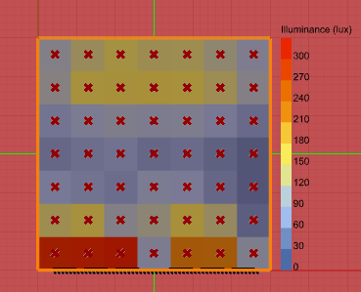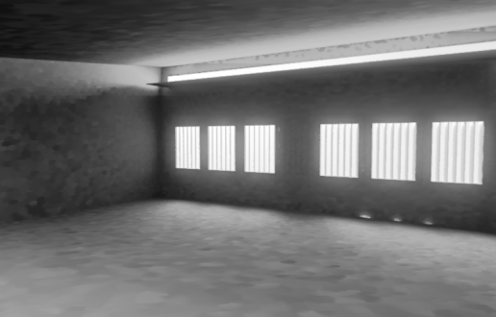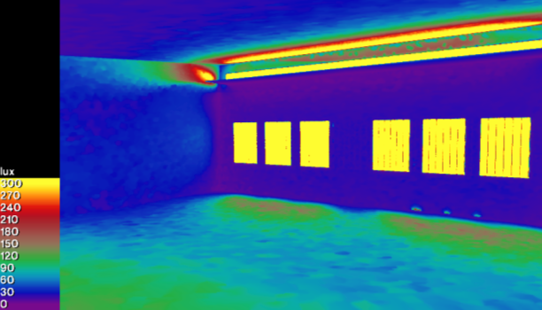
6/21 at 12pm
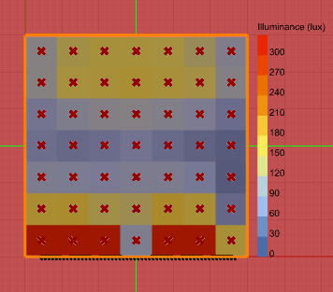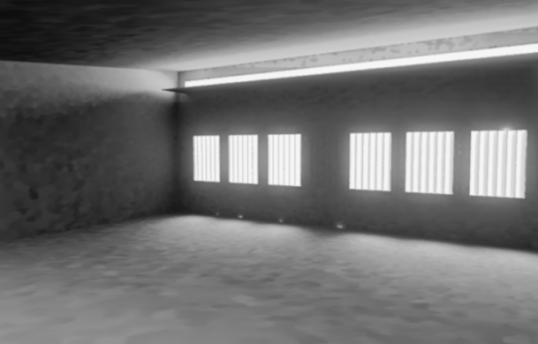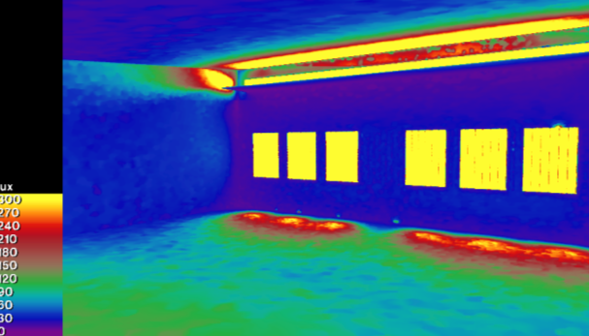
6/21 at 3pm
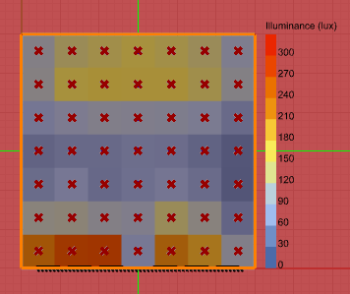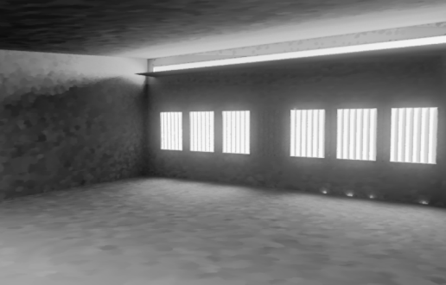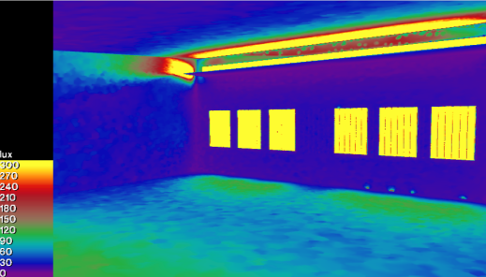
Sunny w sun
6/21 at 9am
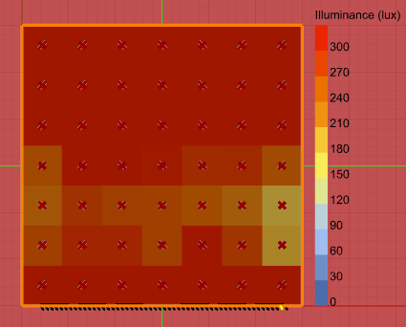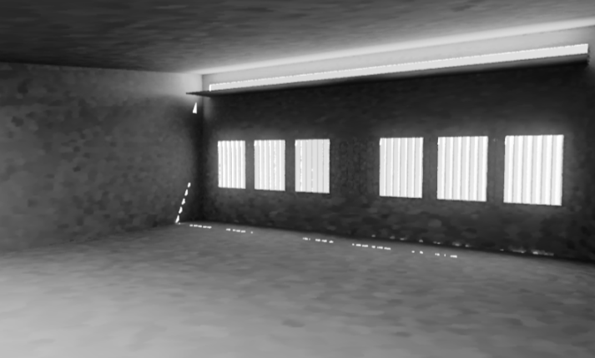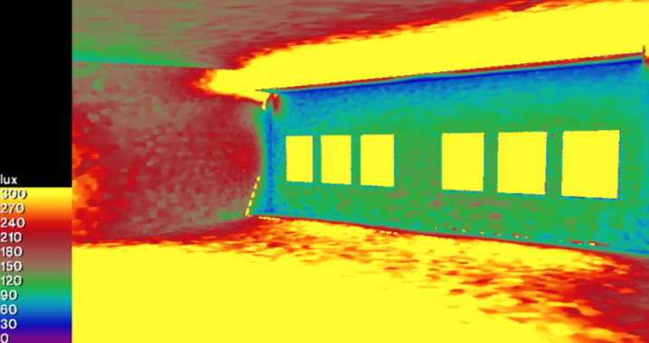

6/21 at 12pm
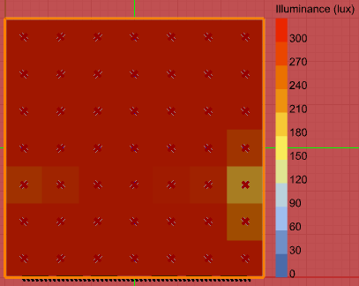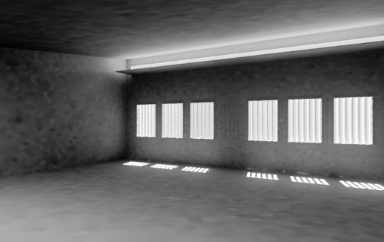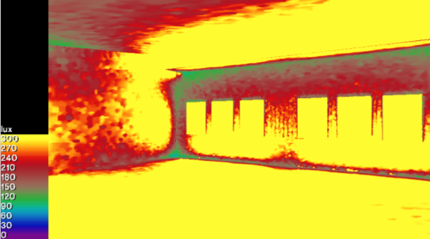
6/21 at 3pm
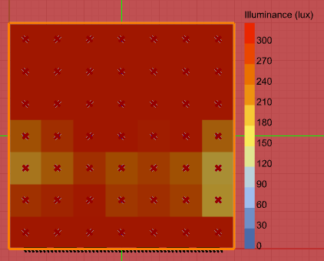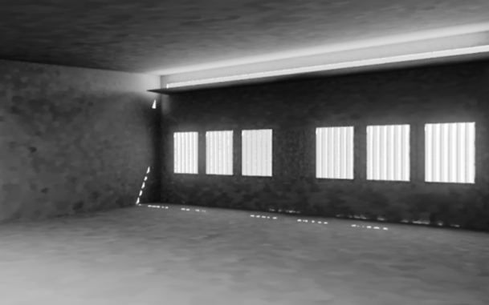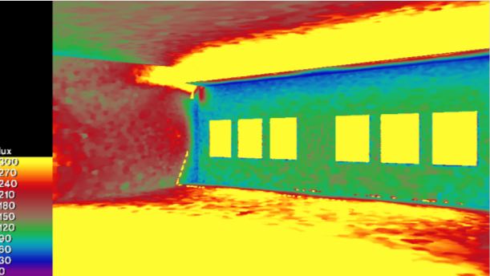
12/21 at 9am
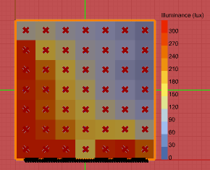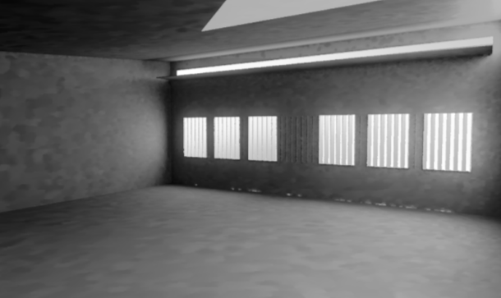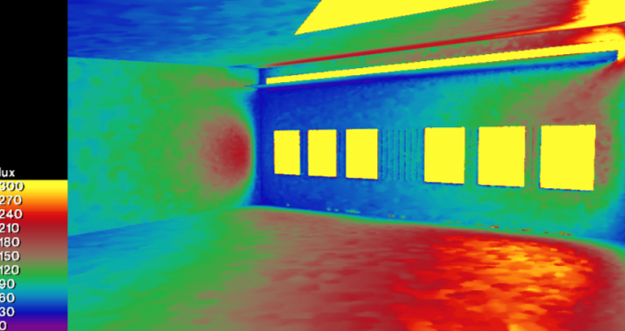
12/21 at 12pm
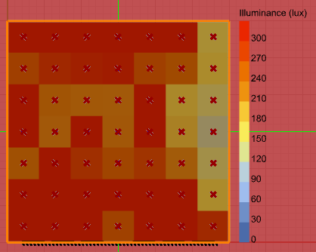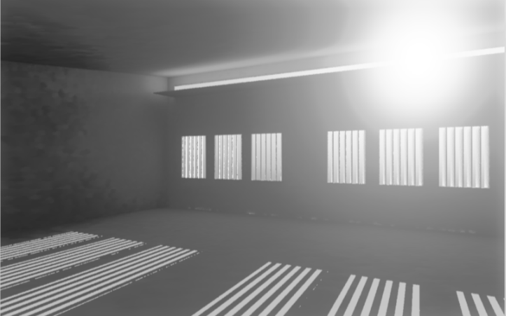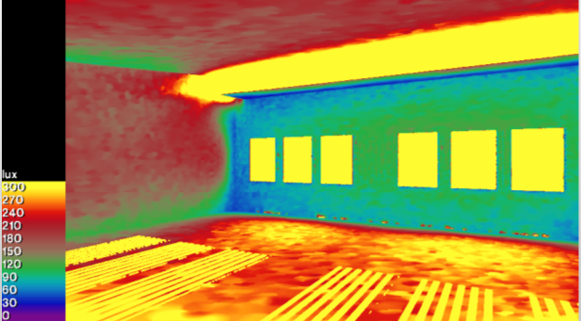
12/21 at 3pm
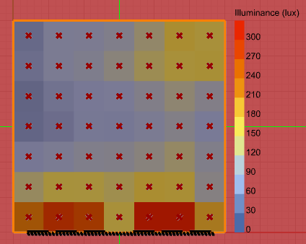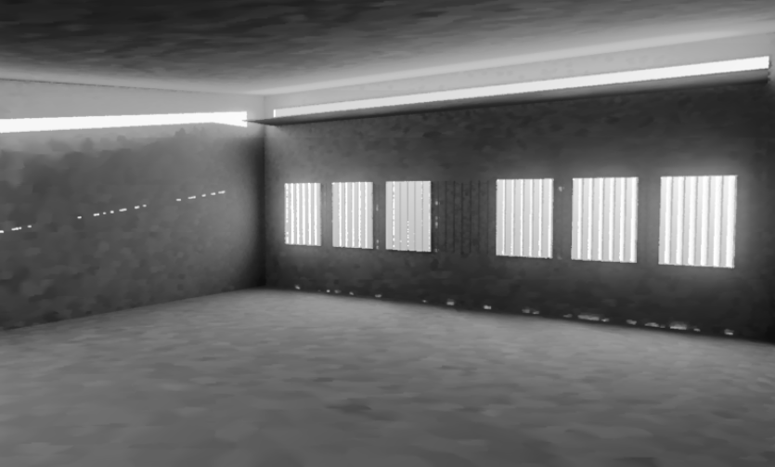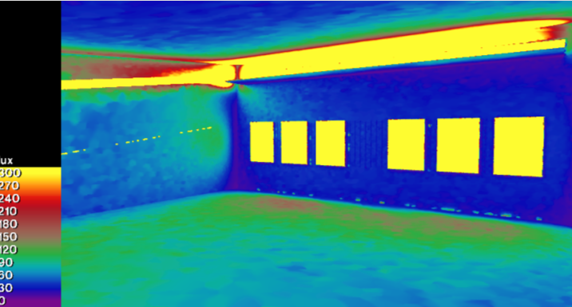

9/21 at 9am
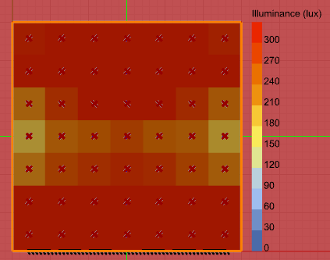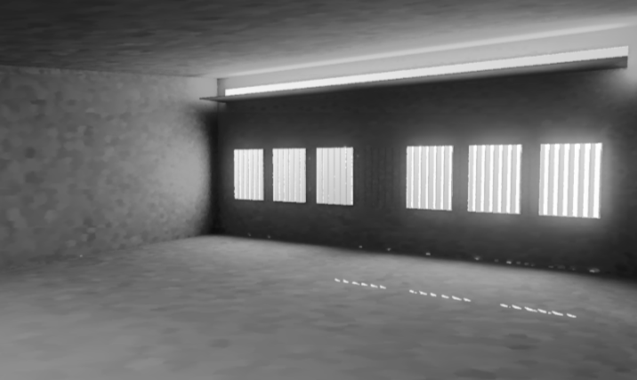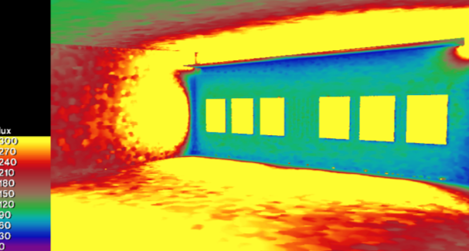
9/21 at 12pm
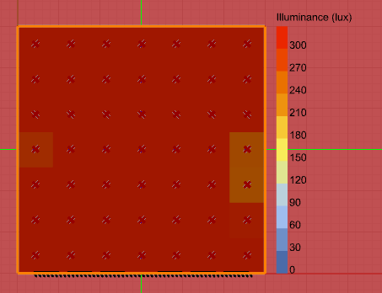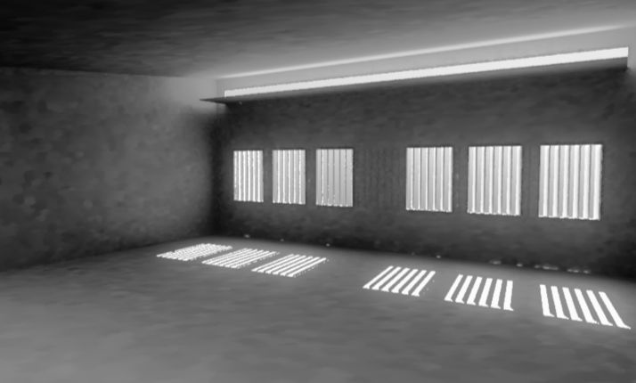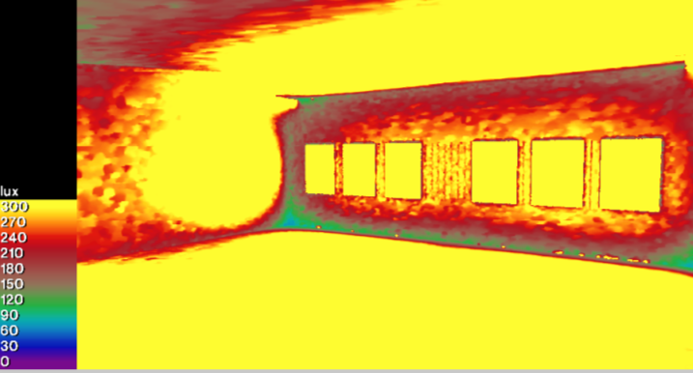
9/21 at 3pm
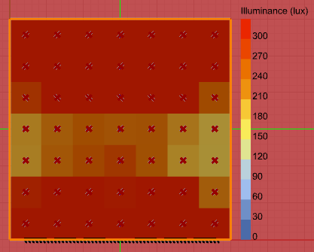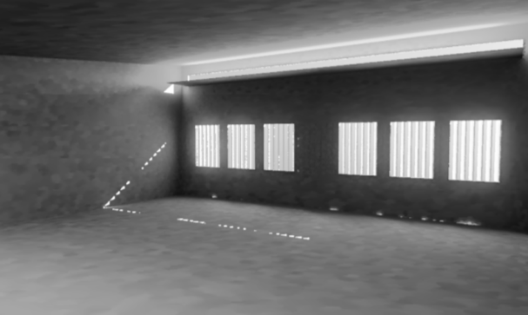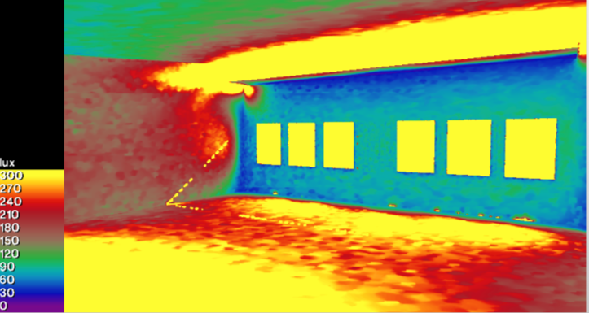

Cloudy
6/21 at 12pm
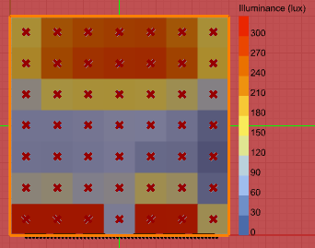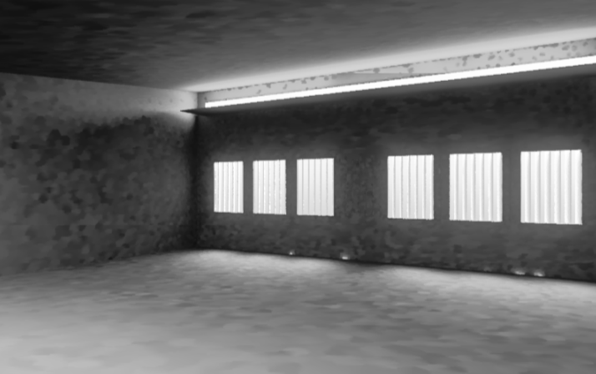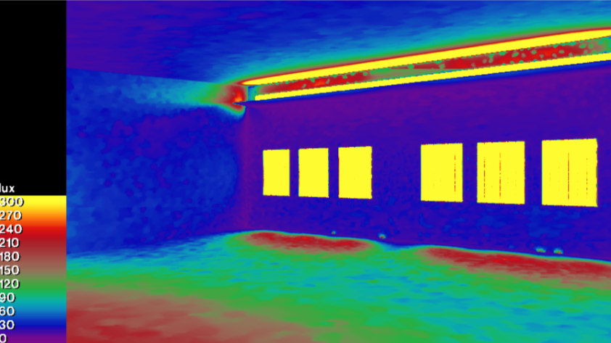
9/21 at 12pm
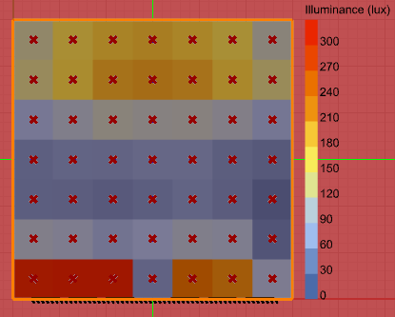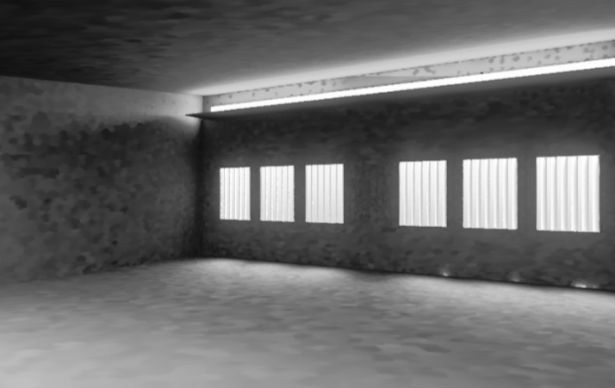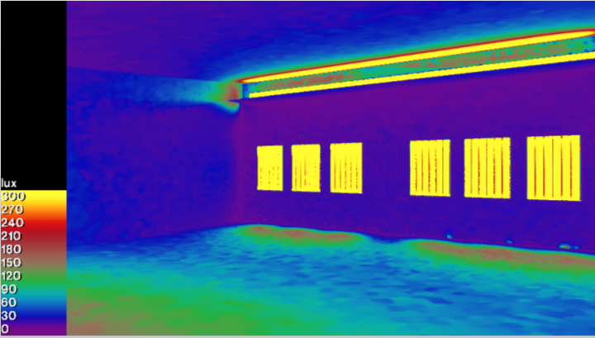
12/21 at 12pm
